https://pgcomputers19.blogspot.com/2023/10/pg-computer.html

[pg computers](https://pgcomputers19.blogspot.com/?m=1)

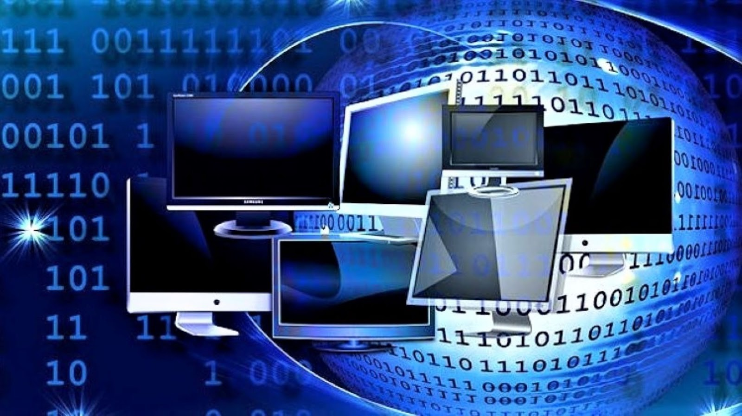

**pg computer**

[October 11, 2023](https://pgcomputers19.blogspot.com/2023/10/pg-computer.html?m=1)

Computer information technology, or IT, is a relatively new ﬁeld that ﬁrst emerged in the 1990s when computers became the basic tools used for work and everyday life. With the rise in computer use came the need for professionals that could develop and maintain their infrastructure. Computer information technology is often used to refer to technical support, but it’s become much more than that.

[computer is programming languages](https://pgcomputers19.blogspot.com/search/label/computer is programming languages?m=1)

[Powered by Blogger](https://www.blogger.com/) [Report Abuse](https://www.blogger.com/go/report-abuse)